1. You need to use (( )) to get output of arithmetic operations.

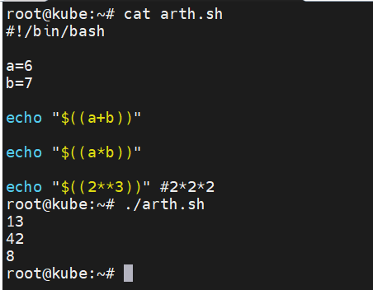

More example as below.

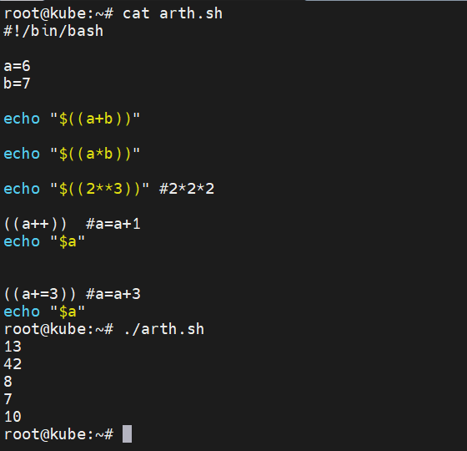

1. Different ways to write the function.

Note: Output will be the same.

Function is useful when you are writing same lines multiple times in one code.

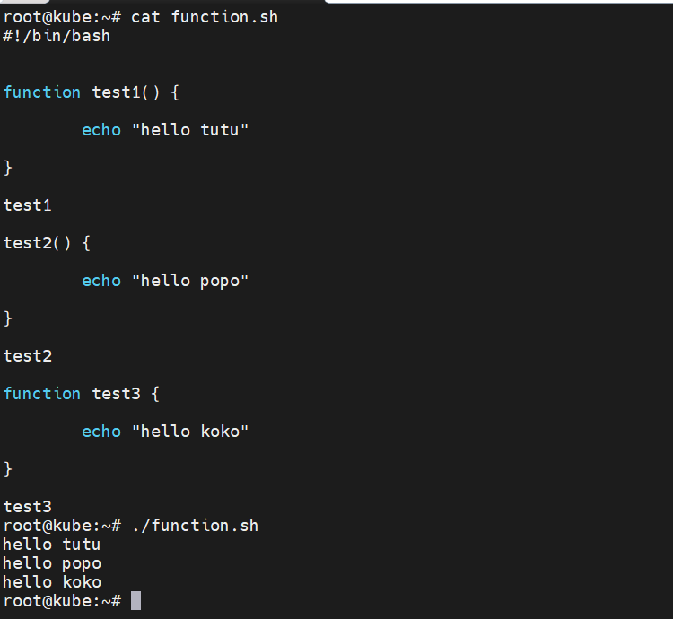

You can change the sequence of function after writing all functions (at end) as shell script runs/check code sequentially. Also, you can call the function in other function.

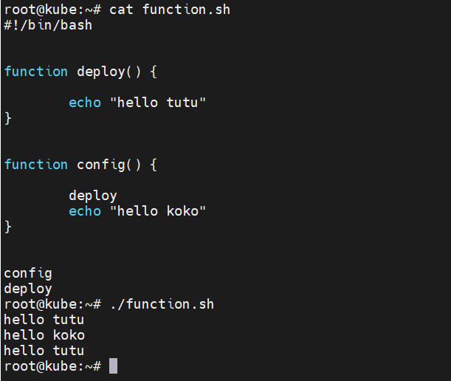

Passing argument in function.

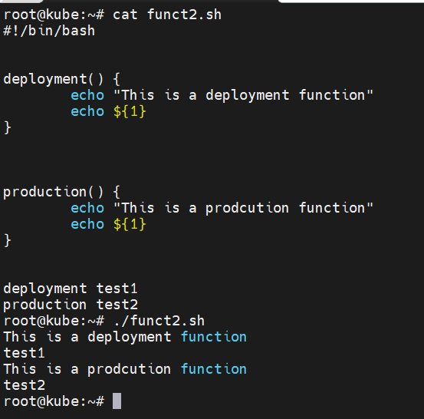

Displaying function name by using system defined variable.

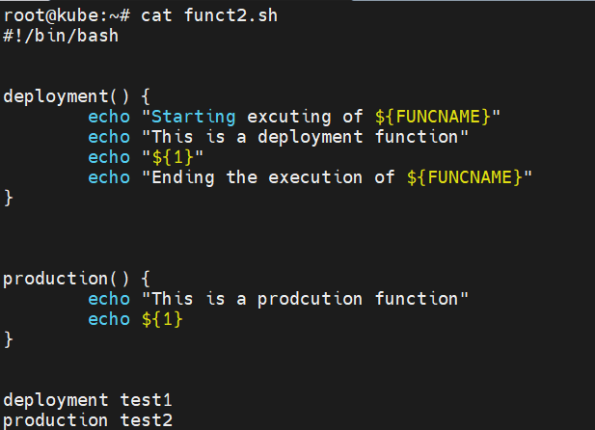

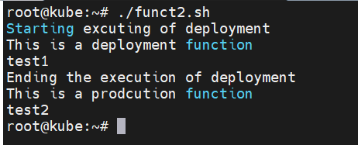

Defining local variable in function.

